**PSD2 Payment Services Directive**

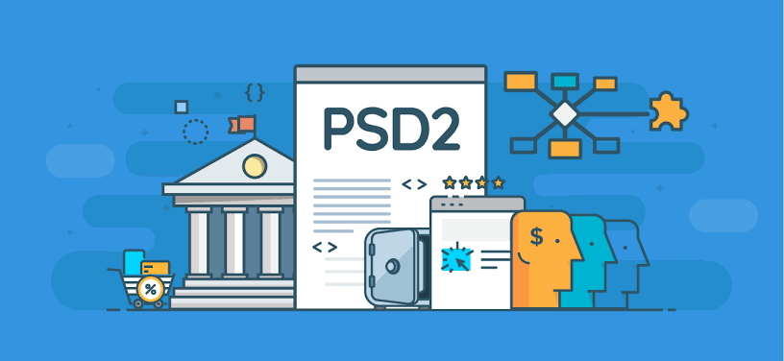

***What is PSD2 ?***

PSD2 is the second Payment Services Directive, designed by the countries of the European Union. It could revolutionise the payments industry, affecting everything from the way we pay online, to what information we see when making a payment.

The Directive's purpose was to increase pan-European competition and participation in the payments industry also from non-banks, and to provide for a level playing field by harmonizing consumer protection and the rights and obligations for payment providers and users.

PSD2 (second Payment Services Directive) is the European Union’s regulation that mandates banks to open up access to accounts and customer data (e.g. payment details) to third-parties. Of course, customers that want to use third-party apps to manage their finance, need to give a permission to get access to their banking data.

The new EU Payments Services Directive (PSD2) took effect on 13th January 2018, bringing in new laws aimed at improving consumer rights.  
  
However, some of its more disruptive regulations are still working their way through the EU Parliament and won’t come into force until September 2019 at the earliest. It can all be a bit confusing, so let us give you a brief overview of what PSD2 entails and when its various elements take effect. PSD2 follows on from the original Payment Services Directive (PSD), which was adopted by the EU in 2007.

**HISTORY and taking EFFECT of PSD2**

The oldest items in the capsule would be the most charming, dating back to bygone eras such as 500 BC Lydia where irregularly shaped disks of electrum (a naturally occurring alloy of gold and silver) were used as the first coins to trade. Or 1659 Britain where a faded, rumpled piece of parchment on which is written the instruction to honor a £400 payment to a Mr. Delboe acted as the first ever cheque written.  
  
Closer to modern times the items in the capsule would become more recognizable yet no less nostalgic, like the first plastic charge card used in 1966, the first ATM ‘hole in the wall’ that debuted in 1967 and even the advent of real-time payments in 2008.  
  
These hallmarks represent transformational moments in the history of payments, but it’s hard to recognize them as such until enough time has passed to appreciate the breadth and depth of their impact on the entire industry. So what does that mean for January 13th 2018, the day Open Banking and PSD2 became a reality in the U.K.?

Ultimately, the detail of January 13th 2018 will evolve and set a new mark in history. Guessing is always a poor science and our collective thoughts and feelings on Open Banking and PSD2 will take many years to develop before logging itself into the next time capsule. All we know for sure is that the new digital journey in financial services has started and everything we held as true in the past is now open to change.

**IMPACT OF PSD2**

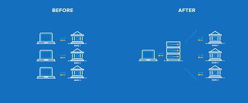

Businesses need to get ready for the changes coming into force with PSD2, and the huge opportunities for breaking into the payment services market. PSD2 should help to level the playing field and present more opportunities for innovation.

Startups have the advantage of being able to adopt disruptive new business models and move very quickly. Forward-thinking entrepreneurs will jump on this chance to make a profit.  
  
Existing businesses can modify their service offering and take advantage of their brand name to quickly gain the trust of consumers looking for new payment services. Consumers can get ready for a slew of new products and services that make managing their finances and buying online much easier.

While the upcoming PSD2 regulations are focused on banking and financial institutions throughout the European Union, that doesn't mean the impact won't be felt elsewhere. After all, the digital economy has turned every business into a global business.

**IMPACT ON BANKS**

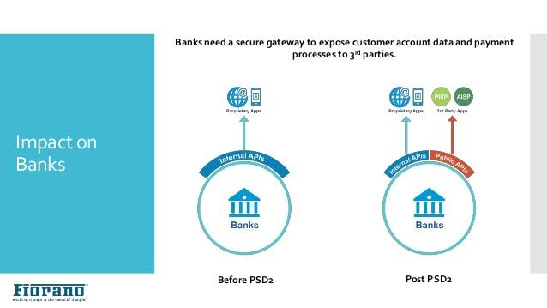

The intense popularity of fintech is one indication that the industry is ripe for disruption. Many banks have slowly started to respond to the fact that consumers are dissatisfied with their services. Companies such as the UK’s first mobile bank Atom Bank, and competitor Monzo, are digital financial services that have gained great popularity. With PSD2, true disruption is becoming more of a real possibility.  
  
Banks have to comply with very strict regulations, which is one barrier that prohibits their innovation. To overcome this, some banks have already been scrambling to invest in fintech startups, and three of the largest fintech investors are international banks.

Indeed, our recent survey of regional and domestic banks shows that increased pressure on pricing and margins is a top concern for bank executives as they plan for the implementation of PSD2.2  
  
In particular, account-to-account (A2A) payments alternatives will pose a serious threat to card issuing and acquiring businesses, not only on pricing but potentially on speed as well, if combined with the SEPA Instant Credit Transfer (SCT Inst) scheme.

**IMPACT ON CUSTOMERS**

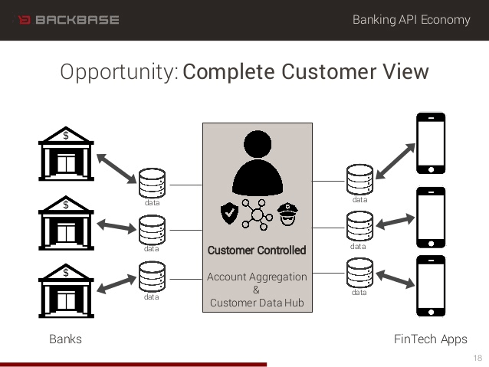

In January 2018, when the directive first comes into place, the mainstream financial services customer will probably notice very little indeed. However by January 2019, a very different set of financial services ecosystems will have started to form. They may take a while to shape, settle, and populate but change will be afoot. A new breed of competition should see a wholesale improvement in services offered and available to customers from all walks. That is why so many are excited about this change, as customers will get better products and services. That feels good to know.

Whether customers come on board remains to be seen but I am of the opinion that great products and services will rise, and the general standard of banking interfaces will also need to rise. That means open data and APIs will have made life better for people and from a customer’s perspective, should be viewed as a positive.

# **MAJOR CHANGE**

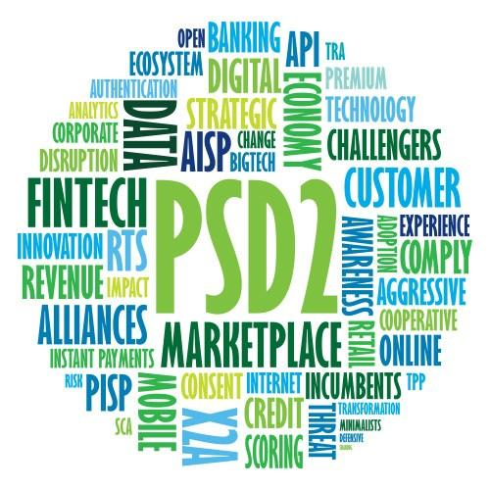

The PSD2 also seeks to cover all currencies, not just the Euro, that are being transacted through financial institutions in the European Union. The directive also will expand its scope to “One-leg transactions”, which is when money either is entering or leaving the EU, not being transacted within it. These types of transactions were mostly exempt from the first payment services directive. As mentioned before, the PSD2 also includes many aspects that enhance consumer protection, including improved authentication and identity management. That means open data and APIs will have made life better for people and from a customer’s perspective, should be viewed as a positive.

**OPPORTUNITY**

PSD2 presents significant opportunities to grow new revenue streams, capture customer ownership and progress toward an extended ecosystem centered on the Everyday Bank. The imperative for banks is to leverage API integration and their existing customer relationships to develop a customer value ecosystem centered on their own banking portals.

**CHALLENGEs**

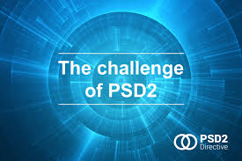

One way that PSD2 opens up for non-banks is through open APIs. By using banks’ APIs non-banks can enter the financial market without the heavy compliance and infrastructure which banks are required to maintain. This opens up the financial market to new entrants with fresh ideas about how to shape the banking experience. Some banks have already started making their APIs available. Examples hereof are the Danish Saxo Bank, that opened up for their APIs in September 201510 and Capital One, a UK based bank, that already now enables affiliates to benefit through their APIs.

**CONCLUSION**

The PSD2 will certainly be a game changer in the Europe-  
an fintech industry and banking sector. It will be enforced shortly before another major revised directive, the General Data Protection Regulation (GDPR). Administrative pressure on banks and payment service providers will be immense in 2018. Will the EU manage to streamline online payments and improve competition in the European market? Or have they opened a Pandora’s box that will cripple the European market with overregulation?

# **Helpful Resources**

repository of links that talk about PSD2 and were used for your sources

PSD2 Wikipedia Article:

<https://en.wikipedia.org/wiki/Payment_Services_Directive#Revised_Directive_on_Payment_Services_(PSD2)>

PSD2 explained: <https://www.finextra.com/blogposting/12932/psd2-explained-in-3-simple-gifs>

Article from Evry, a Norwegian online banking company: <https://www.evry.com/en/news/articles/psd2-the-directive-that-will-change-banking-as-we-know-it/>

<https://www.evry.com/en/news/articles/psd2-the-directive-that-will-change-banking-as-we-know-it/>

Countries of the EEA (see which countries are affected by the new laws):

<https://countryeconomy.com/countries/groups/european-economic-area>

Summary and history:

<http://eur-lex.europa.eu/legal-content/EN/LSU/?uri=CELEX:32015L2366>

PSD2 :

<https://www.elexica.com/-/media/files/articles/2017/asset%20management/psd2%20legislative%20tracker.pdf>

PSD2, Challenge :

<https://www.trunomi.com/open-banking-psd2-challenge/>

Impacts customers:

<https://support.stripe.com/questions/what-is-the-scope-of-the-surcharge-ban-under-psd2>

Impact of PSD2 Explained:

<https://www2.deloitte.com/lu/en/pages/banking-and-securities/articles/anticipating-challenges-opportunities-psd2.html>

Accenture on PSD2:

[https://www.accenture.com/ca-gen/insight-psd2-opportunities-banks](https://www.accenture.com/ca-en/insight-psd2-opportunities-banks)